NEWCASTLE UNIVERSITY ACCOMMODATION INFORMATION FOR USS 2015 GUESTS
Welcome.
You will be staying at Castle Leazes halls of residence, off Barrack Road - postcode NE2 4NY (short link to Google map here: https://goo.gl/maps/o7NgJ, link to campus map here: http://www.ncl.ac.uk/documents/Campus-Map-Print.pdf) It is conveniently located close to the campus, about 10-15 minutes’ walk from the Percy Building which is the main venue for USS 2015. The site plan showing the footpath to campus is overleaf.
ARRIVAL, KEYS AND ACCESS
Castle Leazes is a large complex with several blocks of student residences. Please report to the main reception when you arrive and the staff there will be able to explain the layout and direct you to your block, as well as providing keys and explaining access information. Head for Holland Road and follow signs for Reception on arrival.
Keys should be collected on arrival from Reception. Thereafter please ensure that you carry your key/card/fob with you at all times. You will be charged for replacement keys. The main entrance will lock automatically at 2000 Mon-Fri and 1800 weekends. Card or Code access is required for the main entrance; card/fob is required to access some blocks; key/card/fob is required for access to bedrooms and some kitchens.
Essential contact information
Customer Services 0191 208 8300
Estates Security Service 0191 208 6817
Reception opening times
Mon-Fri 0800-2000
Sat 0900-1800
Sun 0930-1800

Security and Safety
Estates Security Service can be contacted 24 hours of the day via the help point in reception or at the main entrance. Please be aware that building works are taking place and contractors will be working on the site.
CONTACT CUSTOMER SERVICES OR ESTATES SECURITY SERVICES IF YOU NEED ASSISTANCE. Please contact Customer Service if you need help with repairs or maintenance – at Reception, or on the number above. Major problems will be attended to by the Estates Security Services out of hours, and essential repairs carried out.
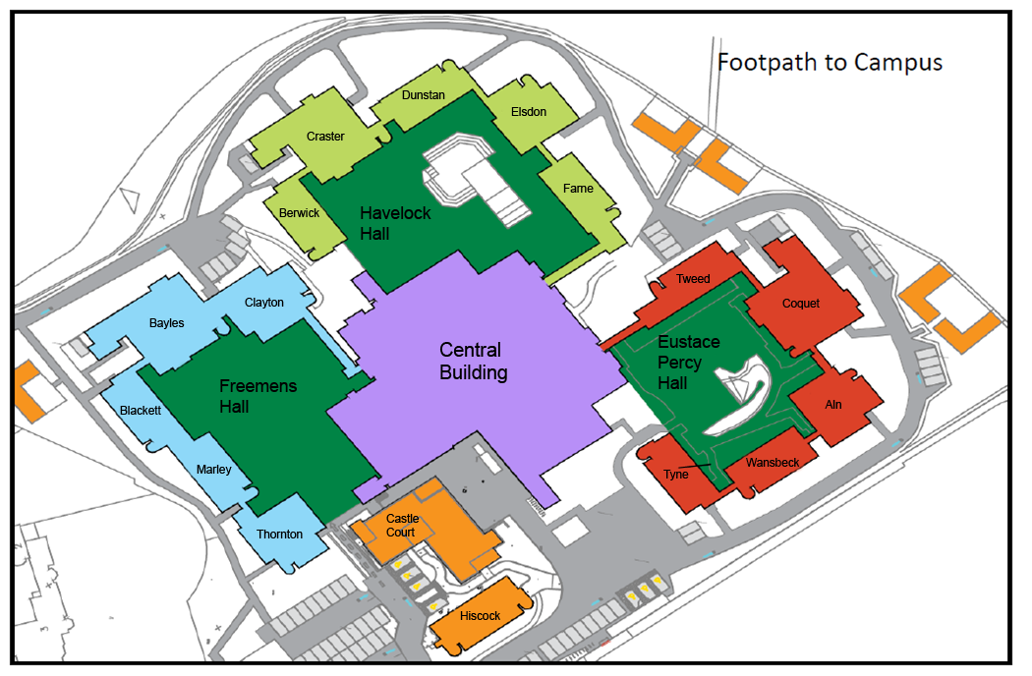

CASTLE LEAZES SITE PLAN

ROOM SERVICING / SHOWERS AND TOILETS / KITCHENS
En-suite bedrooms serviced daily. Towels are provided; if you require new towels please put the old ones on the bathroom floor. Tea and coffee-making facilities provided in the bedroom and in the kitchens.
Standard bedrooms are serviced for stays of three nights or more. Towels are provided; towel change available on request – leave a notice outside your door. Tea and coffee-making facilities provided in the kitchen and replenished daily. Communal showers and toilet facilities are cleaned daily. Please place refuse in the kitchen and it will be removed at the end of your stay.
Kitchen facilities in the halls are limited; they are designed to enable guests to prepare drinks and snacks rather than full meals.
BREAKFAST AND CATERING
Breakfast is served 0800-0900 in Eat@Castle Leazes, located on the first floor of the central block. Accessed by the staircase from the entrance lobby for Havelock Hall or lift from the lobby of Freemens Hall.
The Castle Leazes Bar is located on the first floor of the central block. IT can be accessed from the staircase in the entrance lobby for Eustace Percy Hall.
CAR PARKING
Parking is limited and available on a first-come, first-served basis. Parking cannot be booked in advance.
Other facilities
TV rooms located at the entrance lobbies for Eustace Percy and Havelock Hall. Snooker room at the entrance lobby of Havelock Hall in the central block.
Computer cluster located in the entrance lobby for Havelock Hall in the central block. Locked by security at midnight.
Vending machines located in the central block corridor near the entrance to Eustace Percy Hall.
Toilet facilities located on the ground floor of the central block. Accessible toilets are available – require a radar key for access.
CODE OF CONDUCT
Please behave in a responsible manner at all times. The university has a strict no smoking policy except in designated areas, and a zero tolerance policy regarding illegal substances and legal highs.

EMERGENCIES
If you hear a continuous alarm sounding, evacuate the building immediately.
If you hear a phased/intermittent alarm, evacuate to a lower floor where the alarm is not sounding.
There is a fire alarm test Wednesdays 1100 weekly.
Red ‘break glass’ call points are located at each storey exit and final block exit. Press the black button to sound fire alarm.
Green emergency door release boxes are located at final exit doors and some alternative escape route doors. Activate by pressing the black button if doors do not open automatically in the case of an emergency.
Fire blankets are provided in kitchens, fire extinguishers are provided at strategic locations for use by trained staff only.
Fire action notices are provided in all blocks for your information; please familiarise yourself with the fire notices and Emergency Exits.

Campus Map
